Issue 1: QA code for rita_app_service_operation_supplier_name is failed. 61 Records are impacted.

SELECT distinct SRC1.NAME,

SRC1.Organization_NAME,TRGT.rita_app_service_operation_supplier_name

FROM

(

SELECT SRC.NAME,SRC.sourceinstance,

GROUP_CONCAT(DISTINCT Organization) AS Organization_NAME,

GROUP_CONCAT(DISTINCT CARDINAL_CODE) AS CARDINAL_CODE

FROM pandg_mdsdb.pg_mega_pgb_application_rita_final SRC

LEFT JOIN

(SELECT a.app_hexid,a.responsible_org_unit_hexid,a.sourceinstance,Count(1)

FROM pandg_mdsdb.pg_mega_pgv_app_responsible_org_person_final a

WHERE (a.pg_service_manager_supplier<>'N' AND a.pg_service_manager_supplier IS NOT NULL AND a.pg_service_manager_supplier<>' ' )

AND a.app_hexid IS NOT NULL AND a.responsible_org_unit_hexid IS NOT NULL

group by 1,2,3) ORG ON SRC.NAME=ORG.app_hexid AND SRC.sourceinstance=ORG.sourceinstance

LEFT JOIN

(SELECT distinct b.NAME,LEFT((CARDINAL),255) AS CARDINAL_CODE,GENERICLOCALNAME,sourceinstance,

LEFT(replace(replace(replace(GENERICLOCALNAME, '[0000000000000000]',''),CONCAT('- ',CARDINAL),''),CARDINAL,'') ,255) AS Organization

FROM pandg_mdsdb.pg_mega_pgb_org_unit_final b

WHERE (b.CARDINAL IS NOT NULL AND b.CARDINAL<>'')) SE_CODE ON ORG.responsible_org_unit_hexid=SE_CODE.NAME AND ORG.sourceinstance=SE_CODE.sourceinstance

AND SRC.cdctype<>'D'

GROUP BY SRC.NAME

) SRC1

LEFT JOIN

pandg_mdwdb.d_rita_application_c TRGT ON SRC1.NAME=TRGT.row_id AND SRC1.sourceinstance=TRGT.source_id

WHERE COALESCE(SRC1.Organization_NAME,'UNSPECIFIED')<>TRGT.rita_app_service_operation_supplier_name;

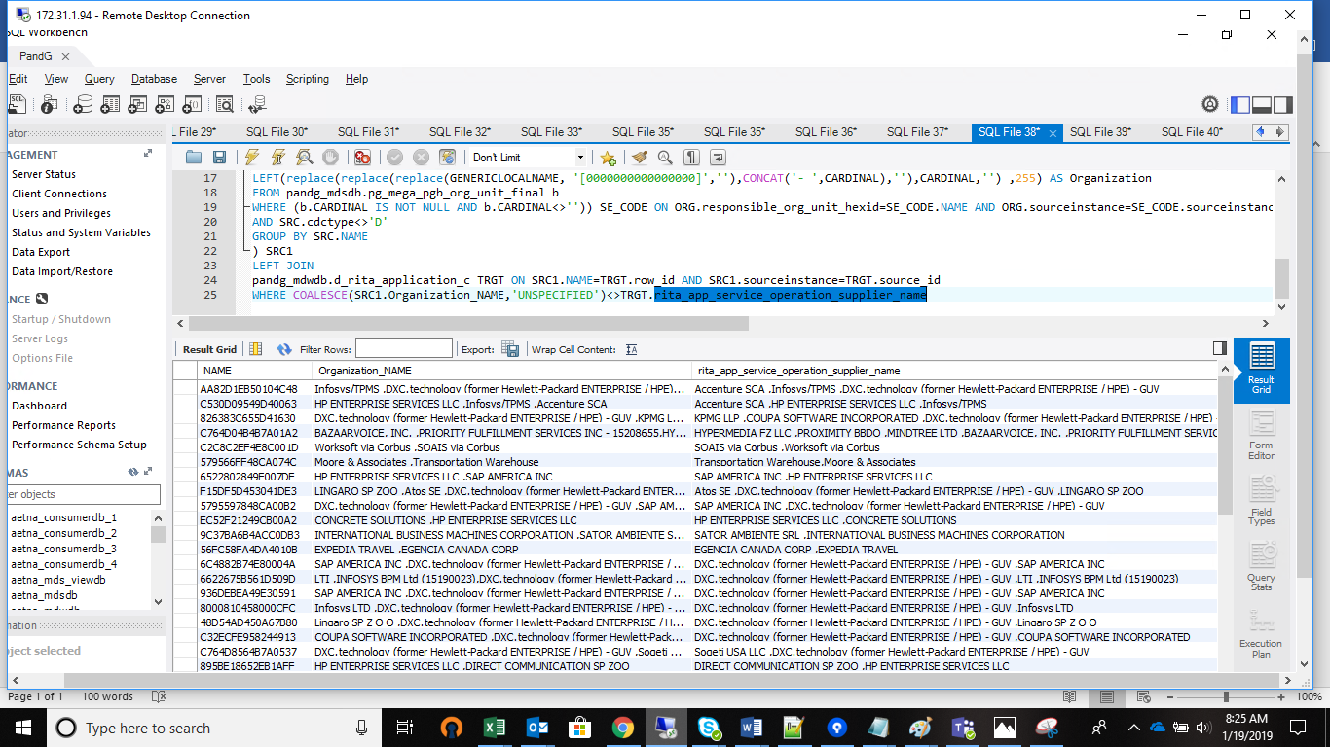

Issue 2:’ rita_app_service_operation_supplier_code’ failed for 63 records :

SELECT COALESCE(SRC1.CARDINAL_CODE,'UNSPECIFIED'),TRGT.rita_app_service_operation_supplier_code

FROM

(

SELECT SRC.NAME,SRC.sourceinstance,

GROUP_CONCAT(DISTINCT Organization) AS Organization_NAME,

GROUP_CONCAT(DISTINCT CARDINAL_CODE) AS CARDINAL_CODE

FROM pandg_mdsdb.pg_mega_pgb_application_rita_final SRC

LEFT JOIN

(SELECT a.app_hexid,a.responsible_org_unit_hexid,a.sourceinstance,Count(1)

FROM pandg_mdsdb.pg_mega_pgv_app_responsible_org_person_final a

WHERE (a.pg_service_manager_supplier<>'N' AND a.pg_service_manager_supplier IS NOT NULL AND a.pg_service_manager_supplier<>' ' )

AND a.app_hexid IS NOT NULL AND a.responsible_org_unit_hexid IS NOT NULL

group by 1,2,3) ORG ON SRC.NAME=ORG.app_hexid AND SRC.sourceinstance=ORG.sourceinstance

LEFT JOIN

(SELECT distinct b.NAME,LEFT((CARDINAL),255) AS CARDINAL_CODE,GENERICLOCALNAME,sourceinstance,

LEFT(replace(replace(replace(GENERICLOCALNAME, '[0000000000000000]',''),CONCAT('- ',CARDINAL),''),CARDINAL,'') ,255) AS Organization

FROM pandg_mdsdb.pg_mega_pgb_org_unit_final b

WHERE (b.CARDINAL IS NOT NULL AND b.CARDINAL<>'')) SE_CODE ON ORG.responsible_org_unit_hexid=SE_CODE.NAME AND ORG.sourceinstance=SE_CODE.sourceinstance

AND SRC.cdctype<>'D'

GROUP BY SRC.NAME

) SRC1

LEFT JOIN

pandg_mdwdb.d_rita_application_c TRGT ON SRC1.NAME=TRGT.row_id AND SRC1.sourceinstance=TRGT.source_id

WHERE COALESCE(SRC1.CARDINAL_CODE,'UNSPECIFIED')<>TRGT.rita_app_service_operation_supplier_code

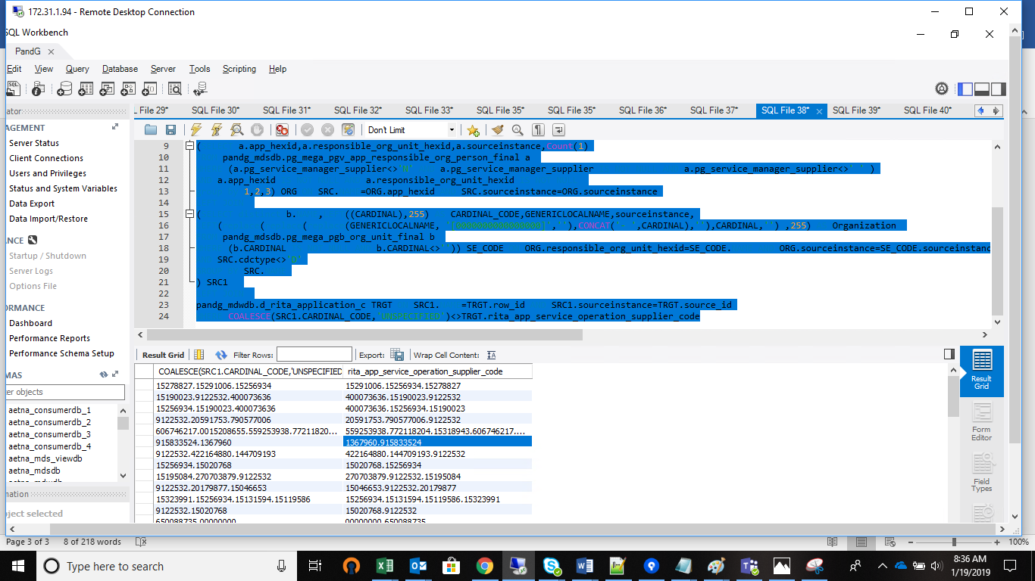

Same issue for rita_app_software_supplier_name/ rita_app_software_supplier_code

SELECT COALESCE(SRC1.Organization_NAME,'UNSPECIFIED'),TRGT.rita_app_software_supplier_name

FROM

(

SELECT SRC.NAME,SRC.sourceinstance,

GROUP_CONCAT(DISTINCT Organization) AS Organization_NAME,

GROUP_CONCAT(DISTINCT CARDINAL_CODE) AS CARDINAL_CODE

FROM pandg_mdsdb.pg_mega_pgb_application_rita_final SRC

LEFT JOIN

(SELECT a.app_hexid,a.responsible_org_unit_hexid,a.sourceinstance,Count(1)

FROM pandg_mdsdb.pg_mega_pgv_app_responsible_org_person_final a

WHERE (a.pg_software_supplier<>'N' AND a.pg_software_supplier IS NOT NULL AND a.pg_software_supplier<>' ' )

AND a.app_hexid IS NOT NULL AND a.responsible_org_unit_hexid IS NOT NULL

group by 1,2,3) ORG ON SRC.NAME=ORG.app_hexid AND SRC.sourceinstance=ORG.sourceinstance

LEFT JOIN

(SELECT distinct b.NAME,LEFT((CARDINAL),255) AS CARDINAL_CODE,GENERICLOCALNAME,sourceinstance,

LEFT(replace(replace(replace(GENERICLOCALNAME, '[0000000000000000]',''),CONCAT('- ',CARDINAL),''),CARDINAL,'') ,255) AS Organization

FROM pandg_mdsdb.pg_mega_pgb_org_unit_final b

WHERE (b.CARDINAL IS NOT NULL AND b.CARDINAL<>'')) SE_CODE ON ORG.responsible_org_unit_hexid=SE_CODE.NAME AND ORG.sourceinstance=SE_CODE.sourceinstance

AND SRC.cdctype<>'D'

GROUP BY SRC.NAME

) SRC1

LEFT JOIN

pandg_mdwdb.d_rita_application_c TRGT ON SRC1.NAME=TRGT.row_id AND SRC1.sourceinstance=TRGT.source_id

WHERE COALESCE(SRC1.Organization_NAME,'UNSPECIFIED')<>TRGT.rita_app_software_supplier_name

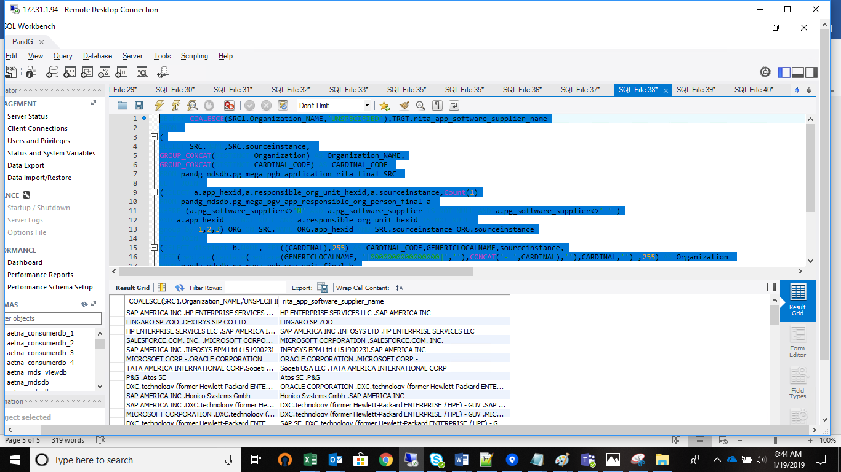

Same issue for rita_app_implementation_supplier_name/ rita_app_implementation_supplier_code

SELECT COALESCE(SRC1.Organization_NAME,'UNSPECIFIED'),TRGT.rita_app_implementation_supplier_name

FROM

(

SELECT SRC.NAME,SRC.sourceinstance,

GROUP_CONCAT(DISTINCT Organization) AS Organization_NAME,

GROUP_CONCAT(DISTINCT CARDINAL_CODE) AS CARDINAL_CODE

FROM pandg_mdsdb.pg_mega_pgb_application_rita_final SRC

LEFT JOIN

(SELECT a.app_hexid,a.responsible_org_unit_hexid,a.sourceinstance,Count(1)

FROM pandg_mdsdb.pg_mega_pgv_app_responsible_org_person_final a

WHERE (a.pg_implementation_supplier<>'N' AND a.pg_implementation_supplier IS NOT NULL AND a.pg_implementation_supplier<>' ' )

AND a.app_hexid IS NOT NULL AND a.responsible_org_unit_hexid IS NOT NULL

group by 1,2,3) ORG ON SRC.NAME=ORG.app_hexid AND SRC.sourceinstance=ORG.sourceinstance

LEFT JOIN

(SELECT distinct b.NAME,LEFT((CARDINAL),255) AS CARDINAL_CODE,GENERICLOCALNAME,sourceinstance,

LEFT(replace(replace(replace(GENERICLOCALNAME, '[0000000000000000]',''),CONCAT('- ',CARDINAL),''),CARDINAL,'') ,255) AS Organization

FROM pandg_mdsdb.pg_mega_pgb_org_unit_final b

WHERE (b.CARDINAL IS NOT NULL AND b.CARDINAL<>'')) SE_CODE ON ORG.responsible_org_unit_hexid=SE_CODE.NAME AND ORG.sourceinstance=SE_CODE.sourceinstance

AND SRC.cdctype<>'D'

GROUP BY SRC.NAME

) SRC1

LEFT JOIN

pandg_mdwdb.d_rita_application_c TRGT ON SRC1.NAME=TRGT.row_id AND SRC1.sourceinstance=TRGT.source_id

WHERE COALESCE(SRC1.Organization_NAME,'UNSPECIFIED')<>TRGT.rita_app_implementation_supplier_name

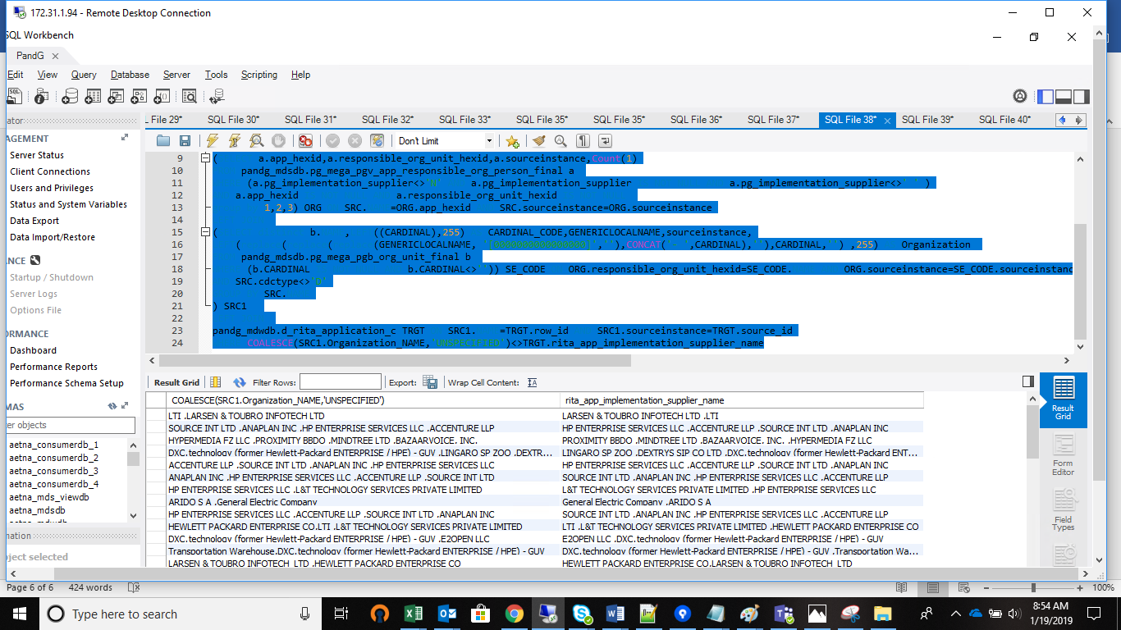

Same issue for rita_app_technology_supplier_name/ rita_app_technology_supplier_code

SELECT COALESCE(SRC1.CARDINAL_CODE,'UNSPECIFIED'),TRGT.rita_app_technology_supplier_code

FROM

(

SELECT SRC.NAME,SRC.sourceinstance,

GROUP_CONCAT(DISTINCT Organization) AS Organization_NAME,

GROUP_CONCAT(DISTINCT CARDINAL_CODE) AS CARDINAL_CODE

FROM pandg_mdsdb.pg_mega_pgb_application_rita_final SRC

LEFT JOIN

(SELECT a.app_hexid,a.responsible_org_unit_hexid,a.sourceinstance,Count(1)

FROM pandg_mdsdb.pg_mega_pgv_app_responsible_org_person_final a

WHERE (a.supplier<>'N' AND a.supplier IS NOT NULL AND a.supplier<>' ' )

AND a.app_hexid IS NOT NULL AND a.responsible_org_unit_hexid IS NOT NULL

group by 1,2,3) ORG ON SRC.NAME=ORG.app_hexid AND SRC.sourceinstance=ORG.sourceinstance

LEFT JOIN

(SELECT distinct b.NAME,LEFT((CARDINAL),255) AS CARDINAL_CODE,GENERICLOCALNAME,sourceinstance,

LEFT(replace(replace(replace(GENERICLOCALNAME, '[0000000000000000]',''),CONCAT('- ',CARDINAL),''),CARDINAL,'') ,255) AS Organization

FROM pandg_mdsdb.pg_mega_pgb_org_unit_final b

WHERE (b.CARDINAL IS NOT NULL AND b.CARDINAL<>'')) SE_CODE ON ORG.responsible_org_unit_hexid=SE_CODE.NAME AND ORG.sourceinstance=SE_CODE.sourceinstance

AND SRC.cdctype<>'D'

GROUP BY SRC.NAME

) SRC1

LEFT JOIN

pandg_mdwdb.d_rita_application_c TRGT ON SRC1.NAME=TRGT.row_id AND SRC1.sourceinstance=TRGT.source_id

WHERE COALESCE(SRC1.CARDINAL_CODE,'UNSPECIFIED')<>TRGT.rita_app_technology_supplier_code

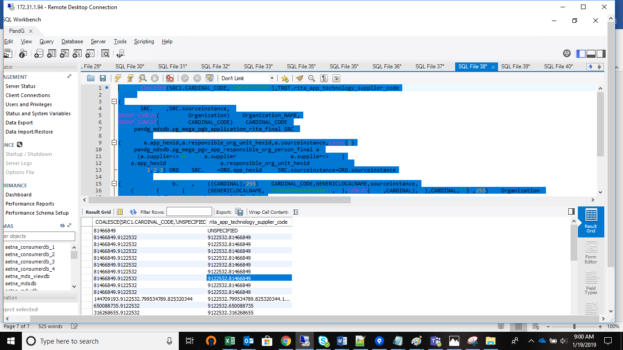

Same case with rita_app_other_supplier_name/ rita_app_other_supplier_code

SELECT COALESCE(SRC1.Organization_NAME,'UNSPECIFIED'),TRGT.rita_app_other_supplier_name

FROM

(

SELECT SRC.NAME,SRC.sourceinstance,

GROUP_CONCAT(DISTINCT Organization) AS Organization_NAME,

GROUP_CONCAT(DISTINCT CARDINAL_CODE) AS CARDINAL_CODE

FROM pandg_mdsdb.pg_mega_pgb_application_rita_final SRC

LEFT JOIN

(SELECT a.app_hexid,a.responsible_org_unit_hexid,a.sourceinstance,Count(1)

FROM pandg_mdsdb.pg_mega_pgv_app_responsible_org_person_final a

WHERE (a.third_party_with_access<>'N' AND a.third_party_with_access IS NOT NULL AND a.third_party_with_access<>' ' )

AND a.app_hexid IS NOT NULL AND a.responsible_org_unit_hexid IS NOT NULL

group by 1,2,3) ORG ON SRC.NAME=ORG.app_hexid AND SRC.sourceinstance=ORG.sourceinstance

LEFT JOIN

(SELECT distinct b.NAME,LEFT((CARDINAL),255) AS CARDINAL_CODE,GENERICLOCALNAME,sourceinstance,

LEFT(replace(replace(replace(GENERICLOCALNAME, '[0000000000000000]',''),CONCAT('- ',CARDINAL),''),CARDINAL,'') ,255) AS Organization

FROM pandg_mdsdb.pg_mega_pgb_org_unit_final b

WHERE (b.CARDINAL IS NOT NULL AND b.CARDINAL<>'')) SE_CODE ON ORG.responsible_org_unit_hexid=SE_CODE.NAME AND ORG.sourceinstance=SE_CODE.sourceinstance

AND SRC.cdctype<>'D'

GROUP BY SRC.NAME

) SRC1

LEFT JOIN

pandg_mdwdb.d_rita_application_c TRGT ON SRC1.NAME=TRGT.row_id AND SRC1.sourceinstance=TRGT.source_id

WHERE COALESCE(SRC1.Organization_NAME,'UNSPECIFIED')<>TRGT.rita_app_other_supplier_name;

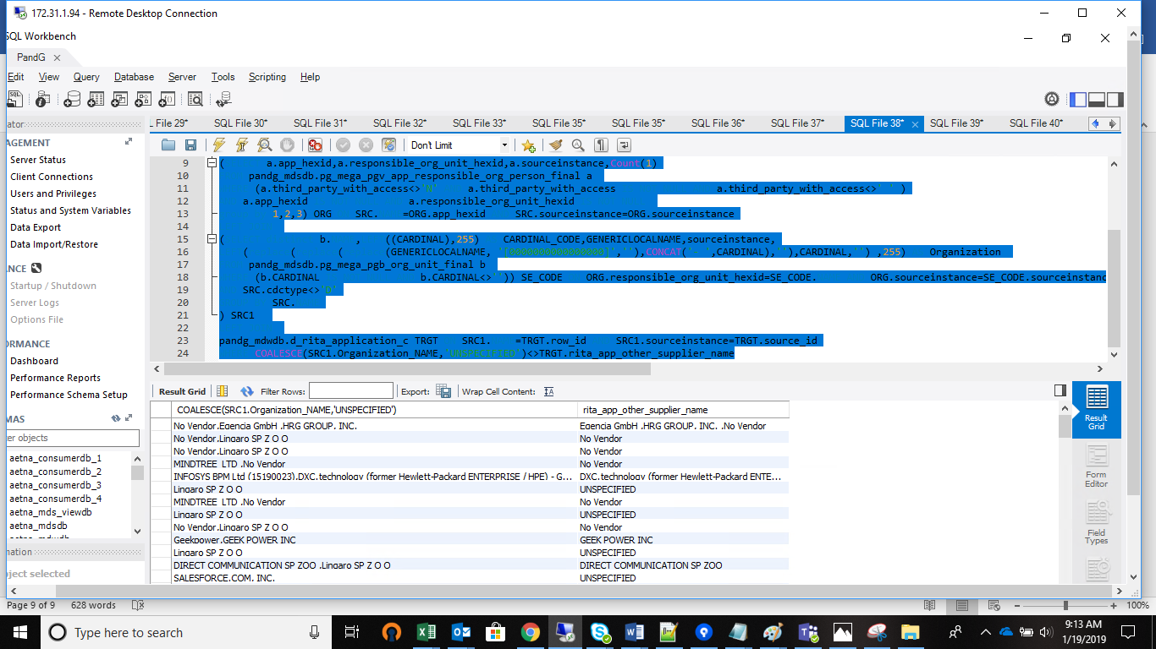

‘rita_application_vendor_manager_name’:

SELECT COALESCE(SRC.person_intranet_id,'UNSPECIFIED'),TRGT.rita_application_vendor_manager_name

FROM

(

SELECT NAME,sourceinstance,GROUP_CONCAT(DISTINCT person_intranet_id) AS person_intranet_id

FROM

(

SELECT

a.NAME,a.sourceinstance,VED.person_intranet_id

FROM pandg_mdsdb.pg_mega_pgb_application_rita_final a

LEFT JOIN

(

SELECT app_hexid,sourceinstance,person_intranet_id,Count(1)

FROM pandg_mdsdb.pg_mega_pgv_app_responsible_org_person_final

WHERE (vendor_application_manager<>'N' AND vendor_application_manager IS NOT NULL AND vendor_application_manager<>'')

AND (app_hexid IS NOT NULL AND person_hex IS NOT NULL and cdctype<>'D')

GROUP by 1,2,3

) VED

ON a.NAME=VED.app_hexid AND a.sourceinstance=VED.sourceinstance

) X

GROUP BY NAME

) SRC

LEFT JOIN

pandg_mdwdb.d_rita_application_c TRGT ON SRC.NAME=TRGT.row_id AND SRC.sourceinstance=TRGT.source_id

WHERE COALESCE(SRC.person_intranet_id,'UNSPECIFIED')<>TRGT.rita_application_vendor_manager_name